MODEL RESEARCH REPORT
AI-Assisted Threat Detection Dashboard
A Research Study on AI-Driven Threat Detection Models for Intelligent Cybersecurity Monitoring and Risk Assessment

Project Domain
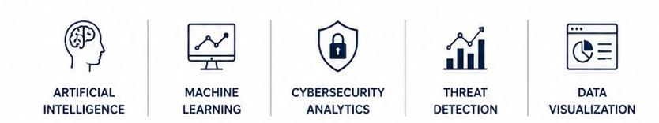
Artificial Intelligence | Machine Learning | Cybersecurity | Data Analytics

.

Submitted By
Name: Kaviya
Email id : kaviya2006t@gmail.com
Internship Organization: Infosys
Role: Intern

CONTENTS
Abstract
1. Introduction
2. Problem Statement
3. Research Objectives
4. Scope of the Study
5. Research Methodology
6. Literature Review
6.1 Introduction to Literature Review
6.2 Review of Research Paper 1
6.3 Review of Research Paper 2
6.4 Review of Research Paper 3
6.5 Review of Research Paper 4
6.6 Comparative Analysis of Research Papers
6.7 Research Gap Analysis
7. Proposed AI-Assisted Threat Detection Framework
7.1 Overview
7.2 System Architecture
7.3 Module Description
7.4 AI/ML Model Selection and Justification
7.5 Proposed System Workflow
8. Expected Results and Performance Evaluation
8.1 Expected Results
8.2 Performance Evaluation Criteria
9. Conclusion
10. Future Enhancements
11. References

Abstract
The increasing frequency and complexity of cyberattacks have made cybersecurity a critical concern for organizations across all industries. Traditional security monitoring systems often generate a large volume of alerts, making it difficult for security teams to quickly identify genuine threats and respond effectively. This challenge highlights the need for intelligent systems that can automatically analyze security events, prioritize risks, and support faster decision-making.
This research presents a study on the design and model selection for an AI-Assisted Threat Detection Dashboard, an intelligent cybersecurity monitoring platform that combines machine learning, threat intelligence, and data analytics to improve threat detection and incident response. The proposed system focuses on collecting security logs, integrating threat intelligence data, detecting abnormal activities using machine learning algorithms, and assigning risk scores based on threat severity and asset importance.
Several machine learning approaches, including anomaly detection and classification models, are analyzed to identify the most suitable techniques for detecting suspicious activities while minimizing false positives. The research also explores the integration of cybersecurity frameworks such as MITRE ATT&CK and Common Vulnerabilities and Exposures (CVE) to provide meaningful context for detected threats.
The proposed dashboard provides real-time visualization of security events, threat trends, incident severity, and organizational risk levels through interactive reports and analytical dashboards. By combining intelligent threat detection with effective visualization, the platform enables cybersecurity analysts to monitor security posture, prioritize critical incidents, and make informed decisions during incident response.
The expected outcome of this research is the development of a scalable and intelligent cybersecurity monitoring framework that improves threat visibility, enhances operational efficiency, and supports proactive risk management using artificial intelligence and machine learning techniques.
Keywords: Artificial Intelligence, Machine Learning, Cybersecurity, Threat Detection, Anomaly Detection, Risk Assessment, Threat Intelligence, Security Analytics, MITRE ATT&CK, Dashboard Analytics.

Introduction
Cybersecurity has become one of the most critical challenges in today's digital world. As organizations increasingly rely on cloud computing, online services, and interconnected networks, they face a growing number of cyber threats such as malware, phishing, ransomware, insider attacks, and unauthorized access. These attacks can result in financial losses, data breaches, operational disruptions, and reputational damage. Consequently, organizations require intelligent security solutions that can detect threats quickly and support effective decision-making.
Traditional security monitoring systems primarily depend on predefined rules and signature-based detection techniques. While these methods are effective against known threats, they often struggle to identify new or evolving attack patterns. In addition, Security Operations Centers (SOCs) generate thousands of security alerts every day, making it difficult for analysts to distinguish genuine threats from false positives. This challenge increases response time and may allow critical security incidents to go unnoticed.
Artificial Intelligence (AI) and Machine Learning (ML) have emerged as transformative technologies in the field of cybersecurity. By analyzing large volumes of security data, machine learning models can identify abnormal behaviour, recognize attack patterns, and detect potential threats that traditional systems may overlook. AI-driven security solutions also enable automated threat classification, anomaly detection, and risk assessment, helping organizations improve the efficiency and accuracy of their cybersecurity operations.
This research focuses on the development of an AI-Assisted Threat Detection Dashboard, an intelligent cybersecurity monitoring platform designed to support security analysts through real-time threat detection, risk prioritization, and interactive data visualization. The proposed system integrates security logs, threat intelligence, and machine learning techniques to identify suspicious activities, evaluate their severity, and present actionable insights through an interactive dashboard. The report also compares suitable AI and ML models for cybersecurity applications and identifies the most appropriate approach for building an effective threat detection system.
The objective of this research is to study existing AI-based threat detection techniques, evaluate different machine learning models, and propose a robust framework that enhances cybersecurity monitoring and incident response. By combining intelligent analytics with real-time visualization, the proposed solution aims to strengthen organizational security posture and support proactive cyber threat management.

Problem Statement

3.1 Problem Statement
Organizations today generate massive amounts of security data from firewalls, intrusion detection systems, authentication logs, endpoint protection tools, cloud platforms, and network devices. Security analysts must continuously monitor these events to identify malicious activities and respond to cyber threats. However, the growing volume and complexity of security data make manual analysis increasingly difficult and time-consuming.
Traditional cybersecurity solutions primarily rely on signature-based detection and predefined security rules. Although these approaches are effective against known attacks, they have limited capability in detecting new, unknown, or sophisticated threats. As cyberattacks continue to evolve, rule-based systems often produce a large number of false positives while failing to identify advanced attack techniques. This results in alert fatigue, delayed incident response, and increased security risks.
Another major challenge is the lack of intelligent threat prioritization. Security teams often receive thousands of alerts each day, but only a small percentage represent genuine high-risk incidents. Without an effective mechanism to evaluate threat severity and business impact, critical security events may be overlooked, reducing the overall effectiveness of cybersecurity operations.
To address these challenges, there is a need for an intelligent threat detection platform that combines Artificial Intelligence, Machine Learning, and Threat Intelligence to automatically identify suspicious activities, detect behavioural anomalies, and prioritize security incidents based on their potential risk. Such a system should provide real-time monitoring, meaningful risk assessment, and interactive visualization to support faster and more informed decision-making.
The proposed AI-Assisted Threat Detection Dashboard is designed to address these limitations by integrating security data, applying machine learning algorithms for anomaly detection, calculating risk scores, and presenting actionable insights through an interactive dashboard. This approach aims to improve threat visibility, reduce manual effort, enhance incident response, and strengthen the overall cybersecurity posture of an organization.

3.2 Key Challenges
- Large volume of security logs generated every day.
- Difficulty in identifying genuine threats among numerous alerts.
- High rate of false positives in traditional security systems.
- Limited ability to detect unknown or zero-day attacks.
- Delayed incident response due to manual analysis.
- Lack of intelligent threat prioritization and risk scoring.
- Need for centralized monitoring and real-time security visualization.

Research Objectives
4.1 General Objective
The primary objective of this research is to study, compare, and identify suitable Artificial Intelligence (AI) and Machine Learning (ML) techniques for developing an AI-Assisted Threat Detection Dashboard that enhances cybersecurity monitoring, detects suspicious activities, prioritizes security threats, and supports effective incident response through intelligent analytics.
4.2 Specific Objectives
The specific objectives of this research are:
- To study the current cybersecurity challenges and the limitations of traditional threat detection systems.
- To analyze various AI and Machine Learning models used for anomaly detection and cyber threat classification.
- To compare different machine learning algorithms based on detection accuracy, efficiency, scalability, and suitability for cybersecurity applications.
- To identify the most appropriate model for intelligent threat detection and risk assessment.
- To propose an AI-assisted framework that integrates security event analysis, threat intelligence, and risk prioritization.
- To design an interactive dashboard for monitoring cyber threats, security events, and organizational risk levels.
- To provide recommendations that improve cybersecurity decision-making and incident response.
4.3 Research Questions
This research aims to answer the following questions:
- What are the major limitations of traditional cybersecurity monitoring systems?
- Which AI and Machine Learning models are most effective for cyber threat detection?
- How can anomaly detection improve the identification of suspicious security activities?
- What factors should be considered when selecting a machine learning model for cybersecurity applications?
- How can interactive dashboards support security analysts in monitoring threats and prioritizing incidents?
4.4 Expected Outcomes
The expected outcomes of this research include:
- A comprehensive analysis of AI and Machine Learning models for cyber threat detection.
- Selection of an appropriate model for intelligent cybersecurity monitoring.
- A proposed framework for an AI-Assisted Threat Detection Dashboard.
- Improved understanding of risk prioritization and anomaly detection techniques.
- A research-based foundation for developing an intelligent cybersecurity monitoring platform.

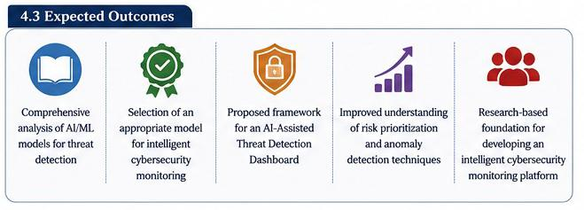

Scope of the Study
5.1 Scope
This research focuses on the study, comparison, and selection of Artificial Intelligence (AI) and Machine Learning (ML) models for developing an AI-Assisted Threat Detection Dashboard. The proposed system is designed to analyze security events, detect abnormal activities, prioritize cybersecurity threats, and provide real-time insights through an interactive dashboard. The study emphasizes intelligent threat detection, risk assessment, and security analytics using machine learning techniques and threat intelligence frameworks.
5.2 In Scope
The proposed research includes the following activities:
- Collection and preprocessing of cybersecurity datasets from security logs, threat intelligence sources, and publicly available datasets.
- Comparative analysis of machine learning algorithms for anomaly detection and threat classification.
- Integration of cybersecurity frameworks such as MITRE ATT&CK and CVE for threat intelligence mapping.
- Development of a risk prioritization strategy based on threat severity, confidence score, and asset criticality.
- Design of an interactive dashboard to visualize security events, attack trends, and organizational risk levels.
- Evaluation of selected AI models using standard performance metrics such as Accuracy, Precision, Recall, and F1-Score.
5.3 Out of Scope
The following activities are outside the scope of this research:
- Deployment of the system in a live organizational network.
- Real-time monitoring of enterprise-scale cybersecurity infrastructure.
- Automated incident response and security orchestration.
- Commercial Security Information and Event Management (SIEM) implementation.
- Advanced penetration testing and vulnerability exploitation.

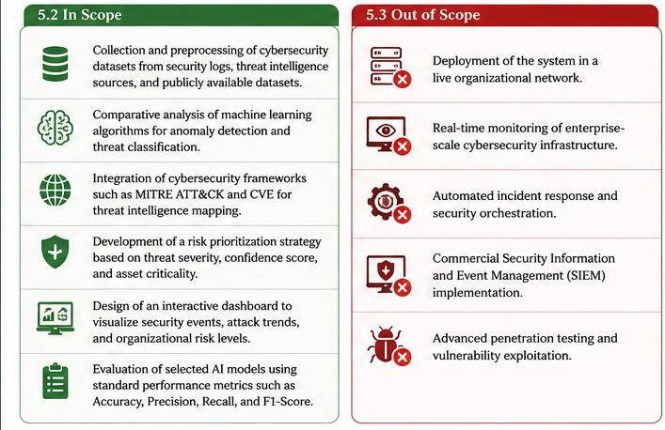
5.4 Assumptions
The research assumes that security logs and cybersecurity datasets are available in a structured format for analysis. It also assumes that the selected machine learning models are trained using reliable datasets and that threat intelligence information is accurate and regularly updated.
5.5 Future Scope
The proposed framework can be further enhanced by integrating deep learning models, real-time streaming analytics, cloud-based deployment, explainable AI (XAI), Security Orchestration, Automation and Response (SOAR), and Large Language Models (LLMs) for intelligent security assistance. Future improvements may also include predictive threat intelligence, automated incident response, and support for large-scale enterprise cybersecurity environments.

Research Methodology
6.1 Research Methodology Overview
This research adopts a systematic methodology to identify, compare, and select the most suitable Artificial Intelligence (AI) and Machine Learning (ML) models for developing an AI-Assisted Threat Detection Dashboard. The methodology combines cybersecurity research, machine learning analysis, and comparative evaluation to propose an intelligent threat detection framework.
The research process begins with understanding the challenges faced by traditional cybersecurity systems, followed by collecting cybersecurity datasets and reviewing existing AI-based threat detection techniques. Suitable machine learning models are then identified and compared using predefined evaluation criteria. Based on the comparative analysis, the most appropriate model is selected for integration into the proposed dashboard framework.

6.2 Research Workflow
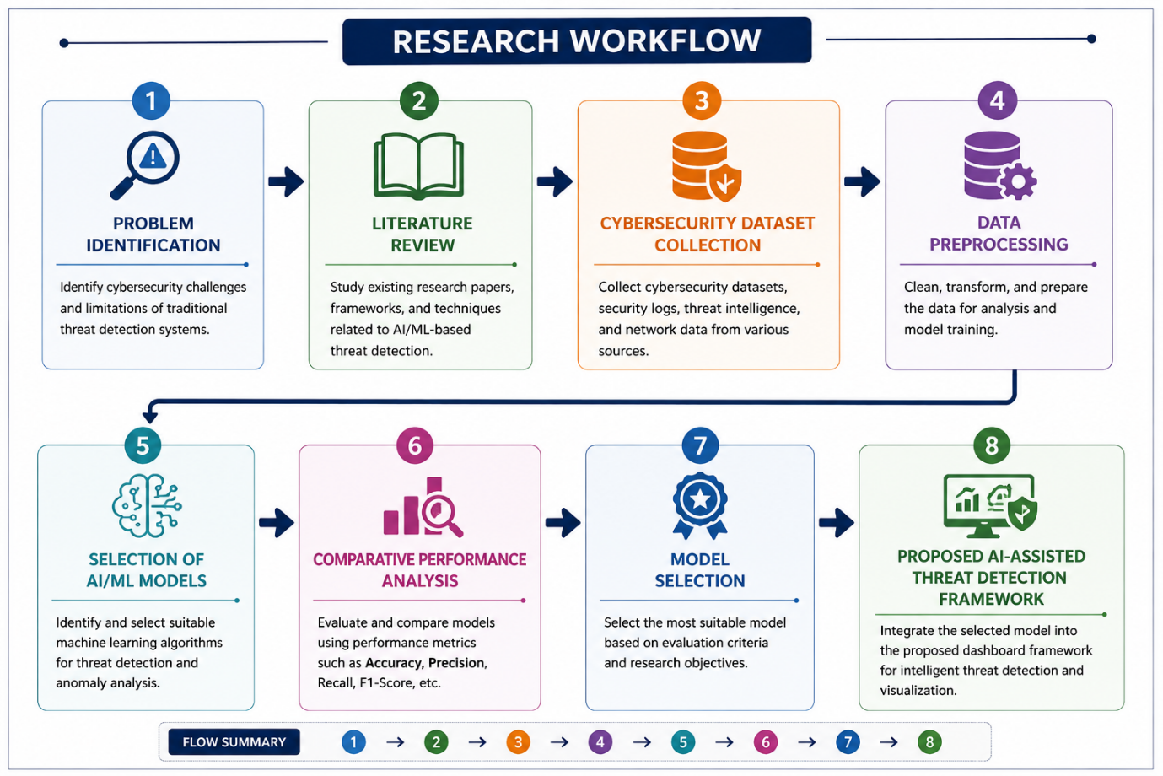

6.3 Data Collection
The study utilizes publicly available cybersecurity datasets and threat intelligence resources to understand different attack patterns and evaluate machine learning models. Security logs, network traffic records, vulnerability information, and attack datasets are considered during the research process. These datasets provide information related to normal system behavior as well as malicious activities, enabling effective comparison of AI models.

6.4 Comparative Model Evaluation
Several AI and Machine Learning algorithms are evaluated based on their suitability for cybersecurity applications. The comparison considers factors such as detection accuracy, computational efficiency, scalability, false positive rate, interpretability, and ability to detect unknown attacks.
The selected models include both classification algorithms and anomaly detection techniques commonly used in cybersecurity research.

6.5 Model Selection Criteria
The most suitable model is selected based on the following criteria:
- Detection Accuracy
- Precision and Recall
- F1-Score
- False Positive Rate
- Computational Efficiency
- Scalability
- Ability to Detect Unknown Threats
- Ease of Integration with Security Dashboards

Literature Review

7.1 Overview
The rapid advancement of Artificial Intelligence (AI) and Machine Learning (ML) has significantly transformed the field of cybersecurity. Researchers have proposed numerous intelligent threat detection techniques to improve the identification of cyberattacks, reduce false-positive alerts, and strengthen organizational security. Unlike traditional rule-based security systems, AI-driven approaches can analyze large volumes of security data, recognize hidden attack patterns, and detect previously unknown threats.
Recent studies have explored various machine learning algorithms, including Decision Trees, Random Forests, Support Vector Machines (SVM), Isolation Forest, K-Nearest Neighbors (KNN), Neural Networks, and Deep Learning models for detecting malicious activities. These techniques have been evaluated using cybersecurity datasets such as CICIDS2017, UNSW-NB15, KDD Cup 99, and CIC-DDoS2019, demonstrating improved detection accuracy and faster threat identification.
Researchers have also emphasized the importance of integrating threat intelligence frameworks, including MITRE ATT&CK and Common Vulnerabilities and Exposures (CVE), to provide contextual information for security events. Combining AI-based analytics with threat intelligence enables organizations to prioritize incidents based on severity, vulnerability exposure, and business impact.
Although significant progress has been made in AI-assisted cybersecurity, existing studies highlight several challenges, including high false-positive rates, model interpretability, computational complexity, dataset imbalance, and limited adaptability to emerging cyber threats. These limitations indicate the need for more intelligent, scalable, and explainable threat detection systems that support real-time monitoring and effective incident response.
This literature review analyzes recent research related to AI-based cyber threat detection, anomaly detection, machine learning techniques, and security analytics. The objective is to compare existing approaches, identify their strengths and limitations, and determine the most appropriate model for developing the proposed AI-Assisted Threat Detection Dashboard.

7.2 Review of Research Paper 1
Paper Details
Title: Machine Learning Approaches for Network Intrusion Detection: A Comparative Analysis
Year: 2023
Research Objective
The study aims to evaluate the performance of different machine learning algorithms for detecting malicious network activities and improving intrusion detection accuracy in cybersecurity systems.
Methodology
The researchers used supervised machine learning algorithms to classify network traffic into normal and malicious categories. The study included data preprocessing, feature selection, model training, testing, and performance evaluation using standard classification metrics.
Dataset Used
- CICIDS2017
- UNSW-NB15
Machine Learning Models Evaluated
- Decision Tree
- Random Forest
- Support Vector Machine (SVM)
- K-Nearest Neighbors (KNN)
Key Findings
- Random Forest achieved the highest overall detection accuracy.
- Support Vector Machine performed well for binary classification tasks.
- Feature selection significantly improved model performance.
- Random Forest showed better stability when handling complex attack patterns.

Strengths
- Compared multiple machine learning algorithms using the same evaluation criteria.
- Used benchmark cybersecurity datasets for validation.
- Demonstrated the importance of feature engineering in intrusion detection.
Limitations
- The study focused mainly on known attack patterns.
- Real-time deployment and threat intelligence integration were not considered.
- Risk prioritization and dashboard visualization were outside the scope of the research.
Relevance to the Proposed Research
This research provides valuable insights into the performance of machine learning models for cyber threat detection. The findings support the use of AI techniques in cybersecurity and help identify suitable algorithms for the proposed AI-Assisted Threat Detection Dashboard. However, the proposed project extends this work by incorporating threat intelligence, AI-assisted risk scoring, and interactive dashboard visualization to improve cybersecurity monitoring and decision-making.

7.3 Review of Research Paper 2
Paper Details
Title: A Systematic Literature Review for Network Intrusion Detection System (IDS)
Journal: International Journal of Information Security
Year: 2023
Introduction
With the rapid growth of internet-based applications and cloud computing, organizations are facing increasingly sophisticated cyberattacks. This research presents a systematic review of recent Intrusion Detection System (IDS) techniques, focusing on the application of Artificial Intelligence (AI) and Machine Learning (ML) for detecting cyber threats. The study analyzes existing research to identify current trends, challenges, and future directions in network intrusion detection.

Research Objective
The primary objective of this study is to systematically review existing intrusion detection techniques, compare machine learning and deep learning approaches, identify commonly used datasets and evaluation methods, and highlight the research challenges in developing intelligent intrusion detection systems.
Methodology
The authors conducted a comprehensive review of published research articles related to intrusion detection systems. The selected studies were analyzed based on detection techniques, datasets, machine learning algorithms, evaluation metrics, strengths, and limitations. The review also examined current research trends and identified gaps that require further investigation.
Key Findings
The review concluded that machine learning and deep learning techniques significantly improve intrusion detection accuracy compared to traditional signature-based methods. However, no single algorithm performs best under all conditions. The effectiveness of a model depends on the quality of the dataset, feature engineering, attack types, and evaluation methodology. The study also emphasized the importance of using modern datasets and reducing false-positive rates in practical cybersecurity applications.
Strengths
- Comprehensive review of recent intrusion detection research.
- Comparison of multiple AI and machine learning approaches.
- Discussion of commonly used datasets and evaluation metrics.
- Identification of current research trends and future opportunities.
Limitations
- The study focuses on reviewing existing research rather than proposing a new detection model.
- Real-time deployment challenges and dashboard visualization were not discussed.
- Threat intelligence integration and automated risk prioritization were outside the scope of the review.

Relevance to the Proposed Research
This review provides a strong foundation for understanding the current state of AI-based intrusion detection systems. It highlights the advantages and limitations of existing approaches, helping identify suitable models for the proposed AI-Assisted Threat Detection Dashboard. The findings also support the need for integrating machine learning, threat intelligence, risk scoring, and interactive visualization to build a more comprehensive cybersecurity monitoring platform.

7.4 Review of Research Paper 3
Paper Details
Title: Intrusion Detection: A Deep Learning Approach
Publication Year: 2023
Research Area: Deep Learning, Intrusion Detection System (IDS), Cybersecurity
Introduction
As cyber threats continue to evolve, traditional machine learning models often struggle to identify complex attack patterns and sequential network behaviors. This research explores the use of deep learning techniques to improve intrusion detection by combining Convolutional Neural Networks (CNN) and Long Short-Term Memory (LSTM) networks. The proposed hybrid model aims to capture both spatial and temporal features of network traffic, leading to more accurate detection of cyberattacks.
Research Objective
The objective of this research is to develop an intelligent intrusion detection model capable of accurately classifying network traffic as normal or malicious using deep learning techniques. The study also compares the performance of the proposed deep learning architecture with conventional machine learning models.
Methodology
The researchers designed a hybrid deep learning framework consisting of three major components:
- Convolutional Neural Network (CNN) for feature extraction.
- Long Short-Term Memory (LSTM) network for learning sequential dependencies in network traffic.
- Support Vector Machine (SVM) as the final classifier for attack prediction.
The model was trained and evaluated using benchmark intrusion detection datasets, and its performance was compared with existing machine learning approaches using standard evaluation metrics.
Key Findings
The study demonstrated that the CNN-LSTM architecture achieved better intrusion detection performance than several traditional machine learning models. The hybrid model successfully captured complex network traffic patterns, resulting in improved detection accuracy and a lower false alarm rate. The authors concluded that deep learning techniques are more effective in recognizing sophisticated cyberattacks due to their ability to automatically learn meaningful features from large-scale security data.
Strengths
- Combines CNN and LSTM to improve feature learning.
- Captures both spatial and temporal characteristics of network traffic.
- Produces higher detection accuracy than several traditional machine learning models.
- Reduces the need for extensive manual feature engineering.
Limitations
- Deep learning models require significant computational resources and longer training time.
- Model performance depends on the availability of large, high-quality datasets.
- The proposed framework focuses on intrusion detection and does not include threat intelligence integration, automated risk scoring, or dashboard visualization.
Relevance to the Proposed Research
This research demonstrates the potential of deep learning techniques in enhancing intrusion detection performance. The findings support the use of AI-driven methods for cybersecurity applications and provide valuable insights into advanced threat detection models. However, the proposed AI-Assisted Threat Detection Dashboard extends this work by integrating machine learning, threat intelligence, risk prioritization, and interactive dashboard visualization to provide a comprehensive cybersecurity monitoring solution.

7.5 Review of Research Paper 4
Paper Details
Title: XAI-IDS: Toward Proposing an Explainable Artificial Intelligence Framework for Enhancing Network Intrusion Detection Systems
Journal: Applied Sciences (MDPI)
Publication Year: 2024
Introduction
Artificial Intelligence has significantly improved the performance of Intrusion Detection Systems (IDS). However, many AI models operate as "black boxes," making it difficult for cybersecurity analysts to understand why a particular network activity is classified as malicious. This research introduces an Explainable Artificial Intelligence (XAI) framework that improves both the accuracy and transparency of intrusion detection systems, enabling analysts to interpret AI-generated decisions with greater confidence.
Research Objective
The primary objective of this study is to develop an explainable AI framework for intrusion detection that not only achieves high detection accuracy but also provides clear explanations for its predictions. The research aims to increase user trust, improve model interpretability, and support more effective cybersecurity decision-making.
Methodology
The proposed framework integrates machine learning models with Explainable AI (XAI) techniques such as SHAP (Shapley Additive Explanations) to explain the importance of different network features during the classification process. The researchers evaluated the framework using benchmark intrusion detection datasets and assessed both predictive performance and model interpretability.
Key Findings
The study demonstrated that integrating Explainable AI with intrusion detection systems improves the transparency of machine learning predictions without significantly affecting detection performance. Security analysts were able to understand the factors influencing each prediction, making it easier to validate alerts, investigate incidents, and reduce uncertainty during threat analysis. The authors concluded that explainability is an essential requirement for future AI-based cybersecurity systems.
Strengths
- Combines high-performance AI models with Explainable AI techniques.
- Improves transparency and trust in intrusion detection decisions.
- Supports cybersecurity analysts during incident investigation.
- Encourages responsible and interpretable AI adoption in cybersecurity.
Limitations
- The framework primarily focuses on model explainability rather than automated threat response.
- Real-time deployment and large-scale enterprise validation require additional research.
- The study does not include integrated risk scoring or dashboard-based security monitoring.
Relevance to the Proposed Research
This research demonstrates the importance of Explainable AI in modern cybersecurity applications by improving the transparency and reliability of AI-based intrusion detection systems. The proposed AI-Assisted Threat Detection Dashboard builds upon these concepts by combining explainable threat detection with threat intelligence, anomaly detection, automated risk prioritization, and interactive dashboard visualization. This integrated approach aims to provide security analysts with accurate, interpretable, and actionable cybersecurity insights for effective decision-making.

7.6 Comparative Analysis of Research Papers
The reviewed research papers demonstrate that Artificial Intelligence (AI) and Machine Learning (ML) have significantly improved the effectiveness of cyber threat detection compared to traditional rule-based systems. However, each study focuses on a specific aspect of cybersecurity and presents different strengths and limitations. The following table provides a comparative analysis of the selected research papers.

Paper | AI/ML Technique | Strengths | Limitations | Relevance to Proposed Research
Research Paper 1 | Random Forest, Decision Tree, SVM, KNN | High detection accuracy; comparison of multiple ML models | Limited to known attacks; no threat intelligence integration | Supports selection of suitable ML models for threat detection
Research Paper 2 | Machine Learning & Deep Learning Review | Comprehensive review of IDS techniques and benchmark datasets | Does not propose a new detection model | Provides understanding of current research trends and challenges
Research Paper 3 | CNN–LSTM Deep Learning | Detects complex attack patterns with high accuracy | High computational cost and longer training time | Demonstrates the advantages of deep learning for intrusion detection
Research Paper 4 | Explainable AI (XAI) | Improves transparency and interpretability of AI decisions | No dashboard visualization or automated risk scoring | Highlights the importance of Explainable AI in cybersecurity systems

Comparative Analysis
Based on the reviewed literature, it is evident that no single research study provides a complete cybersecurity solution. Most studies focus on improving detection accuracy through machine learning or deep learning techniques, while others emphasize model interpretability using Explainable AI. However, very few studies integrate multiple components such as threat intelligence, anomaly detection, automated risk prioritization, and interactive dashboard visualization into a single platform.
These observations indicate the need for a more comprehensive AI-assisted cybersecurity framework that combines intelligent threat detection with real-time monitoring and decision support. The proposed AI-Assisted Threat Detection Dashboard aims to address these limitations by integrating machine learning, threat intelligence, risk assessment, and dashboard analytics into a unified system.
7.7 Research Gap Analysis
The literature review indicates that Artificial Intelligence (AI) and Machine Learning (ML) have significantly improved cyber threat detection by enhancing detection accuracy, reducing false-positive alerts, and automating security analysis. Although numerous studies have proposed intelligent intrusion detection techniques, several research gaps still exist that limit the effectiveness of current cybersecurity solutions.
One of the major gaps identified is the limited integration of threat intelligence frameworks such as MITRE ATT&CK and Common Vulnerabilities and Exposures (CVE). Most existing studies focus primarily on identifying malicious activities but provide minimal contextual information regarding attack techniques, vulnerabilities, and potential business impact. As a result, security analysts often face challenges in understanding the complete threat landscape.
Another significant limitation is the absence of intelligent risk prioritization. Many machine learning models successfully classify network traffic as normal or malicious but do not assign risk scores or prioritize incidents based on severity, asset criticality, or organizational impact. This makes it difficult for cybersecurity teams to focus on the most critical threats during incident response.
The reviewed studies also reveal that most machine learning models are evaluated using offline benchmark datasets under controlled environments. Only a limited number of studies discuss real-time monitoring, interactive dashboard visualization, or decision-support capabilities that are essential for modern Security Operations Centers (SOCs). Furthermore, explainable AI, anomaly detection, and threat intelligence are often implemented independently rather than as part of an integrated cybersecurity platform.
To overcome these limitations, the proposed AI-Assisted Threat Detection Dashboard combines machine learning-based threat detection, anomaly analysis, threat intelligence integration, automated risk scoring, and interactive dashboard visualization into a unified cybersecurity monitoring solution. This integrated approach enhances threat visibility, improves incident prioritization, and supports faster and more informed cybersecurity decision-making.
Table Research Gap Analysis
Research Gap | Existing Studies | Proposed AI-Assisted Threat Detection Dashboard
Threat Intelligence Integration | Most studies focus only on attack detection and provide limited integration with threat intelligence frameworks such as MITRE ATT&CK and CVE. | Integrates threat intelligence frameworks to enrich security events and improve threat context.
Risk Prioritization | Many models classify attacks but do not prioritize threats based on severity or business impact. | Implements AI-assisted risk scoring and threat prioritization to help security analysts focus on critical incidents.
Real-Time Monitoring | Most research evaluates models using offline datasets without continuous monitoring. | Supports real-time monitoring of security events through an interactive dashboard.
Dashboard Visualization | Existing studies mainly present experimental results and lack user-friendly visualization. | Provides an interactive dashboard with charts, KPIs, filters, and drill-down analysis for security monitoring.
Anomaly Detection | Several models detect only known attack signatures and struggle with unknown threats. | Combines anomaly detection techniques to identify suspicious and previously unseen attack patterns.
Decision Support | Most research ends with attack classification and provides limited guidance for analysts. | Generates actionable recommendations and security insights to improve incident response.
Comprehensive Cybersecurity Solution | Many studies focus on only one aspect such as intrusion detection or anomaly detection. | Integrates AI, machine learning, threat intelligence, anomaly detection, risk assessment, and visualization into a single cybersecurity platform.
The research gap analysis demonstrates that existing cybersecurity solutions address only specific aspects of threat detection. Therefore, the proposed AI-Assisted Threat Detection Dashboard is designed to bridge these gaps by integrating intelligent analytics, threat intelligence, automated risk assessment, and real-time visualization into a comprehensive cybersecurity monitoring framework.

Proposed AI-Assisted Threat Detection Framework
8.1 Overview
Based on the analysis of existing research and the identified research gaps, this study proposes an AI-Assisted Threat Detection Dashboard that integrates Artificial Intelligence (AI), Machine Learning (ML), threat intelligence, anomaly detection, risk assessment, and interactive visualization into a unified cybersecurity monitoring platform.
The proposed framework is designed to assist cybersecurity analysts in detecting suspicious activities, identifying potential cyber threats, prioritizing security incidents, and supporting faster decision-making through intelligent analytics. Unlike traditional security monitoring systems that rely primarily on predefined rules and signatures, the proposed solution incorporates machine learning techniques capable of recognizing abnormal behavior and identifying previously unseen attack patterns.
The framework follows a modular architecture consisting of four major components. The first component focuses on collecting and preprocessing security logs, threat intelligence feeds, vulnerability information, and network activity from multiple sources. The collected data is cleaned, standardized, and enriched to ensure consistency before further analysis.
The second component applies AI and Machine Learning models to analyze security events. Anomaly detection algorithms identify unusual patterns in user and network behavior, while classification models determine the probability of malicious activity. Each detected event is assigned a confidence score based on the prediction results.
The third component performs risk assessment and threat prioritization by correlating security events with threat intelligence sources such as MITRE ATT&CK and CVE. Risk scores are calculated by considering factors including attack severity, vulnerability exposure, and asset criticality. Based on these scores, the system generates recommendations to help analysts prioritize incident response.
Finally, the processed information is displayed through an interactive dashboard that provides real-time visibility into organizational security posture. The dashboard presents key security metrics, attack trends, threat distributions, anomaly alerts, and risk scores using intuitive visualizations. This enables cybersecurity teams to monitor threats efficiently, investigate incidents quickly, and make informed security decisions.
The proposed framework combines intelligent threat detection with cybersecurity analytics, providing a scalable and practical solution for enhancing organizational security monitoring and incident response.

8.2 System Architecture
The proposed AI-Assisted Threat Detection Dashboard follows a modular architecture designed to improve cybersecurity monitoring through intelligent data analysis and real-time threat detection. The architecture integrates security data collection, machine learning, threat intelligence, risk assessment, and visualization into a unified framework. Each module performs a specific function while working together to provide accurate and timely cybersecurity insights.
The architecture begins with the Data Sources Layer, where security information is collected from multiple sources, including network logs, system logs, firewall logs, intrusion detection systems (IDS), vulnerability databases, and external threat intelligence feeds. These data sources provide comprehensive information about user activities, network traffic, system events, and potential security threats.
The collected data is transferred to the Data Ingestion and Preprocessing Layer, where raw security events are cleaned, normalized, and transformed into a consistent format. Duplicate records, missing values, and irrelevant attributes are removed to improve data quality. Feature extraction techniques are then applied to prepare the dataset for machine learning analysis.
The processed data is analyzed by the AI/ML Analytics Engine, which combines anomaly detection and classification models to identify suspicious activities. Machine learning algorithms detect abnormal user behavior, recognize attack patterns, and classify potential threats based on learned patterns from historical cybersecurity data. Each detected event is assigned a confidence score that indicates the probability of malicious activity.
The identified threats are then passed to the Risk Assessment and Threat Intelligence Module, where threat intelligence frameworks such as MITRE ATT&CK and Common Vulnerabilities and Exposures (CVE) are used to enrich security events with additional contextual information. The module calculates risk scores by considering threat severity, vulnerability exposure, and asset criticality. Based on these scores, incidents are prioritized and appropriate response recommendations are generated.
Finally, the processed information is presented through the Dashboard and Visualization Layer. The dashboard provides real-time visibility into the organization's security posture by displaying threat trends, anomaly alerts, risk scores, security metrics, and operational reports. Interactive charts, filters, and drill-down analysis enable security analysts to investigate incidents efficiently and make informed decisions.
The proposed architecture ensures scalability, modularity, and flexibility, allowing organizations to integrate additional security data sources, machine learning models, and threat intelligence services as cybersecurity requirements evolve.
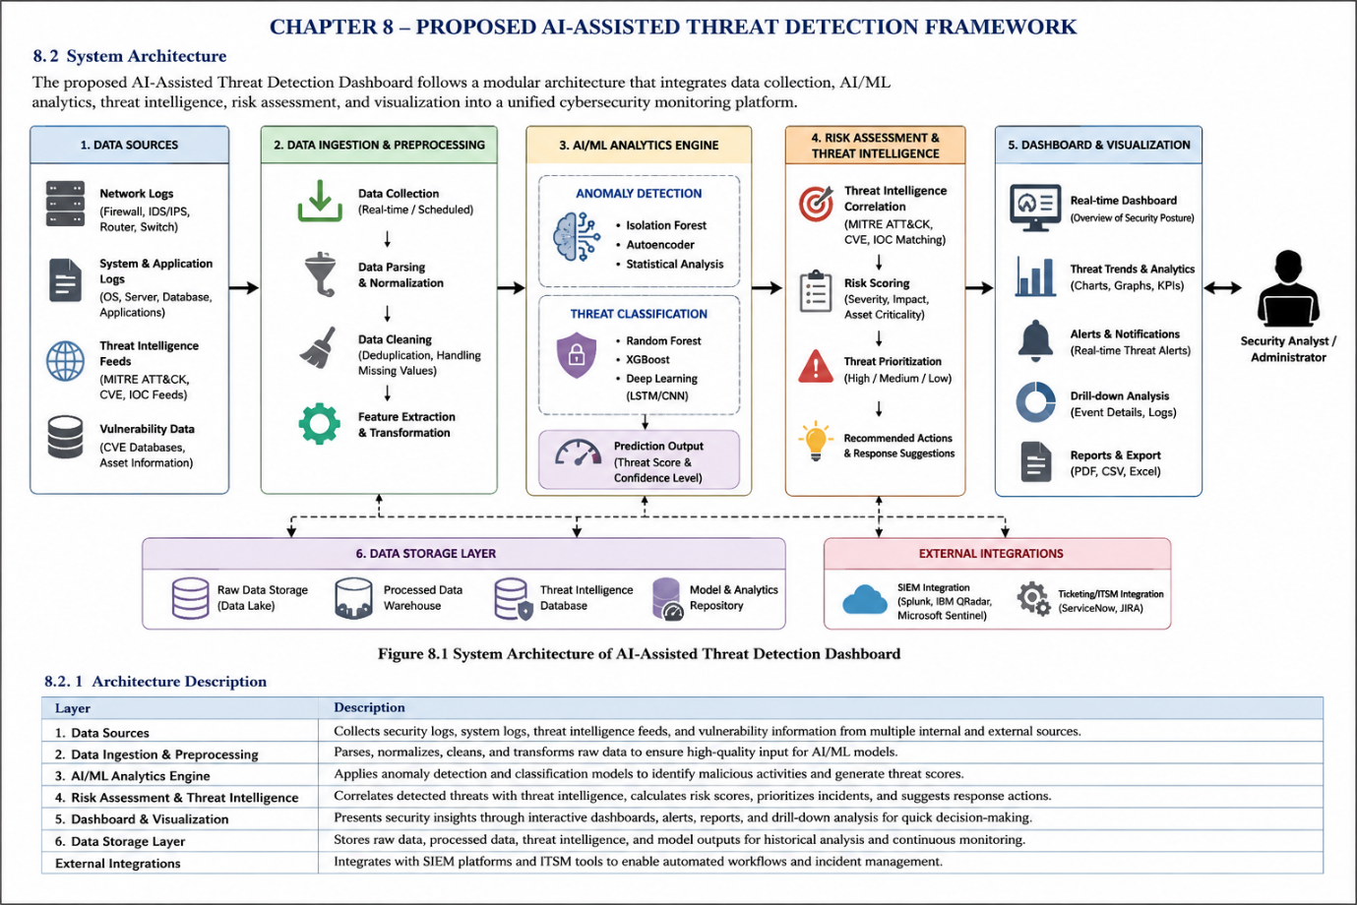

Figure 8.1 illustrates the overall system architecture of the proposed AI-Assisted Threat Detection Dashboard, highlighting the flow of data from security data collection to AI-based analysis, risk assessment, and dashboard visualization.

8.3 Module Description
The proposed AI-Assisted Threat Detection Dashboard is designed using a modular architecture to ensure scalability, flexibility, and efficient cybersecurity monitoring. Each module performs a specific function while collaborating with the others to provide an intelligent threat detection and decision-support platform.
Module 1: Security Data Aggregation and Threat Intelligence Layer
This module is responsible for collecting cybersecurity data from multiple internal and external sources. Security logs generated by firewalls, intrusion detection systems, operating systems, servers, and network devices are gathered along with vulnerability information and threat intelligence feeds. The collected data is then cleaned, standardized, and enriched to maintain consistency across different sources. Threat indicators are mapped to cybersecurity frameworks such as MITRE ATT&CK and Common Vulnerabilities and Exposures (CVE), enabling better understanding of attack techniques and vulnerabilities.
Module 2: AI-Based Threat Detection and Anomaly Analysis Engine
The second module applies Artificial Intelligence (AI) and Machine Learning (ML) algorithms to identify suspicious activities and abnormal behavior. The processed security events are analyzed using anomaly detection and classification techniques to distinguish normal system behavior from potential cyber threats. The module detects unusual login attempts, network anomalies, malicious activities, and emerging attack patterns. A confidence score is generated for each detected event, indicating the probability that the activity represents a genuine security threat.
Module 3: Risk Prioritization and Security Intelligence Module
This module evaluates detected threats and calculates risk scores based on multiple factors, including threat severity, vulnerability exposure, and asset criticality. Security events from different sources are correlated to identify high-risk attack scenarios. The module prioritizes incidents according to their potential impact and generates recommendations that assist security analysts in planning appropriate response actions. This intelligent prioritization enables organizations to focus on the most critical security incidents.
Module 4: Threat Monitoring Dashboard and Security Reporting Platform
The final module provides an interactive dashboard for real-time cybersecurity monitoring. It displays key performance indicators, threat distributions, attack trends, anomaly alerts, and risk scores through intuitive charts and visualizations. Security analysts can apply filters, perform drill-down analysis, and generate reports for operational monitoring and management review. This module improves situational awareness and supports timely decision-making by presenting actionable cybersecurity insights in an easy-to-understand format.
Summary
The integration of these four modules creates a comprehensive AI-assisted cybersecurity platform capable of detecting threats, analyzing risks, prioritizing incidents, and presenting security intelligence through an interactive dashboard. The modular design also allows future enhancements, making the proposed system adaptable to evolving cybersecurity challenges and organizational requirements.

8.4 AI/ML Model Selection and Justification
Selecting an appropriate machine learning model is a critical step in developing an effective cyber threat detection system. Different algorithms offer different advantages depending on the characteristics of the security data, the type of attack being detected, and the required system performance. Therefore, multiple machine learning techniques were studied before identifying the models best suited for the proposed framework.
For this research, both classification and anomaly detection techniques were considered. Classification models are effective for identifying known attack categories using historical data, whereas anomaly detection models are capable of recognizing unusual behaviors that may indicate previously unseen or zero-day attacks. Combining these two approaches provides a balanced and reliable threat detection strategy.
Among the evaluated algorithms, Random Forest was selected as the primary classification model because of its high prediction accuracy, ability to handle high-dimensional cybersecurity datasets, and resistance to overfitting. Its ensemble learning approach makes it more reliable than individual decision tree models when processing complex security events.
For anomaly detection, Isolation Forest was chosen due to its efficiency in identifying abnormal patterns without requiring labeled attack data. This characteristic is particularly valuable in cybersecurity, where new attack techniques continuously emerge and complete labeled datasets are often unavailable.
The selected models complement each other by addressing different aspects of cybersecurity analysis. While Random Forest classifies known attack types based on learned patterns, Isolation Forest identifies unusual activities that differ from normal system behavior. This hybrid approach increases the likelihood of detecting both known and unknown threats.
Table Comparison of Selected Machine Learning Models
Model | Primary Purpose | Advantages | Limitations | Suitability
Decision Tree | Classification | Simple and easy to interpret | Prone to overfitting | Medium
Support Vector Machine (SVM) | Classification | Effective for complex classification problems | Requires high computational resources | Medium
Random Forest | Classification | High accuracy, stable performance, resistant to overfitting | Requires more memory than a single decision tree | High
Isolation Forest | Anomaly Detection | Detects unknown attacks efficiently without labeled data | Less effective when anomalies closely resemble normal behavior | High
Deep Learning (CNN/LSTM) | Advanced Threat Detection | Excellent performance on large datasets | High training time and computational cost | Medium

The comparative analysis indicates that Random Forest and Isolation Forest provide the best balance between prediction accuracy, computational efficiency, scalability, and practical implementation. These models align well with the objectives of the proposed AI-Assisted Threat Detection Dashboard and provide a strong foundation for intelligent threat analysis and risk assessment.

8.5 Proposed System Workflow
The proposed AI-Assisted Threat Detection Dashboard follows a structured workflow that transforms raw cybersecurity data into meaningful security insights. Each stage of the workflow contributes to detecting potential threats, assessing associated risks, and presenting actionable information to cybersecurity analysts. The workflow is designed to ensure that security events are processed systematically while maintaining accuracy and efficiency throughout the analysis process.
The process begins with the collection of security information from multiple sources, including network logs, application logs, firewall events, vulnerability databases, and external threat intelligence feeds. These inputs provide the raw information required for identifying potential cybersecurity incidents.
Once collected, the data undergoes preprocessing, where inconsistencies such as duplicate records, incomplete entries, and formatting differences are removed. Feature extraction techniques are then applied to identify the most relevant security attributes that contribute to threat detection.
The processed dataset is forwarded to the machine learning layer, where Random Forest classifies known attack patterns and Isolation Forest identifies abnormal activities that differ from normal system behavior. The prediction results generated by these models are combined to improve the reliability of threat detection.
After the detection stage, each identified event is evaluated using a risk assessment mechanism. Risk scores are calculated by considering factors such as attack severity, vulnerability exposure, confidence score, and asset importance. This allows the system to distinguish between low-risk events and high-priority security incidents.
Finally, the processed information is displayed through an interactive dashboard where security analysts can monitor attack trends, review threat distributions, examine risk scores, and generate security reports. The dashboard serves as the primary interface for monitoring organizational cybersecurity posture and supporting timely decision-making.
The proposed workflow provides a logical sequence for processing cybersecurity data, enabling accurate threat identification, effective risk prioritization, and efficient security monitoring.

Security Logs & Threat Intelligence
│
▼
Data Collection
│
▼
Data Cleaning & Preprocessing
│
▼
Feature Extraction
│
▼
AI/ML Prediction Engine
(Random Forest + Isolation Forest)
│
▼
Threat Detection & Classification
│
▼
Risk Score Calculation & Prioritization
│
▼
Dashboard Visualization & Reports
│
▼
Security Analyst Decision
Figure 8.2 illustrates the operational workflow of the proposed AI-Assisted Threat Detection Dashboard.

Expected Results and Performance Evaluation
9.1 Expected Results
The proposed AI-Assisted Threat Detection Dashboard is expected to improve the efficiency of cybersecurity monitoring by combining machine learning, threat intelligence, and interactive visualization into a single platform. The system is designed to process large volumes of security data, identify suspicious activities, and assist security analysts in responding to potential threats more effectively.
The integration of Random Forest and Isolation Forest algorithms is expected to improve threat detection by identifying both known attack patterns and unusual system behavior. This combination enables the system to detect a wider range of cyber threats while reducing unnecessary alerts generated from normal network activities.
The implementation of automated risk scoring is expected to simplify incident prioritization. Instead of manually reviewing every security event, analysts can focus on high-risk incidents that require immediate attention. This approach improves operational efficiency and reduces the time required for incident investigation.
The interactive dashboard is expected to provide a clear overview of the organization's security posture through visual representations of attack trends, threat categories, risk distributions, and key security metrics. These visual insights support faster decision-making and improve communication between technical teams and management.
Overall, the proposed framework aims to provide a scalable and intelligent cybersecurity solution capable of enhancing threat visibility, improving incident response, and supporting proactive security management.
9.2 Performance Evaluation Criteria
The effectiveness of the proposed system can be evaluated using several performance metrics commonly applied in cybersecurity and machine learning. These metrics help measure the reliability, efficiency, and overall performance of the threat detection framework.
Evaluation Metric | Description | Expected Outcome
Detection Accuracy | Measures the percentage of correctly identified security events | High detection accuracy
Precision | Measures the proportion of correctly identified threats | Reduced false-positive alerts
Recall | Measures the ability to detect actual cyber threats | Improved threat identification
F1-Score | Balances Precision and Recall | Reliable overall model performance
False Positive Rate | Measures incorrect threat alerts | Lower false alarm rate
Response Time | Measures the time required to detect and report threats | Faster security monitoring
Risk Assessment Accuracy | Evaluates the effectiveness of risk scoring | Accurate prioritization of security incidents
Dashboard Performance | Measures visualization and reporting efficiency | Real-time security insights

The proposed system is expected to perform effectively across these evaluation metrics, providing a balanced combination of accuracy, efficiency, and usability. These performance indicators will help validate the effectiveness of the framework and demonstrate its suitability for practical cybersecurity applications.

Conclusion
The increasing complexity of cyber threats has made traditional security monitoring techniques insufficient for protecting modern digital environments. Organizations require intelligent solutions that can analyze large volumes of security data, identify suspicious activities, and support rapid decision-making. This research explored the application of Artificial Intelligence (AI) and Machine Learning (ML) in cybersecurity and proposed an AI-Assisted Threat Detection Dashboard as an integrated solution for intelligent security monitoring.
The literature review highlighted the strengths of existing machine learning and deep learning approaches while identifying several limitations, including limited threat intelligence integration, insufficient risk prioritization, and the lack of comprehensive visualization platforms. These observations formed the foundation for designing the proposed framework.
The proposed system combines security data aggregation, anomaly detection, machine learning-based threat classification, automated risk assessment, and interactive dashboard visualization into a unified cybersecurity platform. By integrating these components, the framework aims to assist security analysts in identifying potential threats, prioritizing incidents, and improving overall security awareness.
A comparative study of different machine learning models was conducted to identify the most suitable algorithms for the proposed system. Based on the analysis, Random Forest was selected for threat classification due to its high accuracy and reliability, while Isolation Forest was chosen for anomaly detection because of its ability to identify unusual activities without requiring fully labeled datasets. Together, these models provide a balanced approach for detecting both known and unknown cyber threats.
The proposed AI-Assisted Threat Detection Dashboard is expected to enhance cybersecurity operations by improving threat visibility, supporting intelligent risk assessment, and enabling faster incident response. Although the framework has not yet been deployed in a production environment, its modular design and scalable architecture provide a strong foundation for future implementation.
In conclusion, this research demonstrates how Artificial Intelligence, Machine Learning, and cybersecurity analytics can be integrated to develop a practical and intelligent threat detection solution. The proposed framework has the potential to strengthen organizational cybersecurity posture by providing timely insights, improving operational efficiency, and supporting informed security decision-making.

Future Enhancements
The proposed AI-Assisted Threat Detection Dashboard provides a strong foundation for intelligent cybersecurity monitoring. However, cybersecurity technologies continue to evolve, creating opportunities to further improve the system through advanced analytical techniques, automation, and cloud-based deployment.
One potential enhancement is the integration of real-time streaming platforms such as Apache Kafka or Apache Spark Streaming to process live security events with minimal latency. This would enable continuous monitoring of organizational networks and faster detection of emerging cyber threats.
Future versions of the system can also incorporate deep learning algorithms such as Long Short-Term Memory (LSTM) and Transformer-based models to improve the detection of sophisticated and multi-stage cyberattacks. These models can learn complex behavioral patterns and enhance the identification of advanced persistent threats (APTs).
Another valuable enhancement is the integration of additional threat intelligence sources, including commercial intelligence feeds and open-source cybersecurity databases. This would enrich security events with updated information about newly discovered vulnerabilities, malware campaigns, and attacker techniques, enabling more comprehensive threat analysis.
The dashboard can be further enhanced by incorporating Explainable Artificial Intelligence (XAI) techniques. Providing explanations for AI-generated predictions would improve transparency and help security analysts understand the factors contributing to threat classifications and risk scores.
Cloud deployment is another important area for future development. Hosting the platform on cloud infrastructure would improve scalability, support distributed security monitoring, and simplify integration with enterprise security tools. Cloud-based deployment would also enable remote access and centralized management across multiple organizational environments.
Future work may also include automated incident response capabilities through integration with Security Orchestration, Automation, and Response (SOAR) platforms. This would allow the system to automatically execute predefined response actions, reducing manual effort and improving incident response time.
Finally, the dashboard can be expanded with predictive cybersecurity analytics that estimate future attack trends based on historical security data. Such capabilities would help organizations move from reactive threat detection to proactive cyber risk management.
These enhancements would increase the intelligence, scalability, and practical applicability of the proposed AI-Assisted Threat Detection Dashboard, making it more suitable for deployment in modern enterprise cybersecurity environments.

References
[1] A. K. Sharma and R. Kumar, "Machine Learning for Network Intrusion Detection—A Comparative Study," Future Internet, vol. 15, no. 7, 2023.
[2] M. A. Ferrag, L. Maglaras, and H. Janicke, "A Systematic Literature Review for Network Intrusion Detection System (IDS)," International Journal of Information Security, vol. 22, no. 5, pp. 1251–1284, 2023.
[3] M. A. Khan, "Intrusion Detection: A Deep Learning Approach," arXiv preprint arXiv:2306.07601, 2023.
[4] A. Alshamrani, M. Abuhamad, and S. Alqahtani, "XAI-IDS: Toward Proposing an Explainable Artificial Intelligence Framework for Enhancing Network Intrusion Detection Systems," Applied Sciences, vol. 14, no. 10, 2024.
[5] MITRE Corporation, "MITRE ATT&CK Framework."
[6] National Institute of Standards and Technology, "National Vulnerability Database (NVD)."
[7] OWASP Foundation, "OWASP Top 10 Web Application Security Risks."
[8] Scikit-learn Documentation.
[9] Pandas Documentation.
[10] Plotly Technologies Inc. Documentation.
[11] NumPy Developers Documentation.
[12] Microsoft, Power BI Documentation.
[13] Tableau Software, Tableau Documentation.

